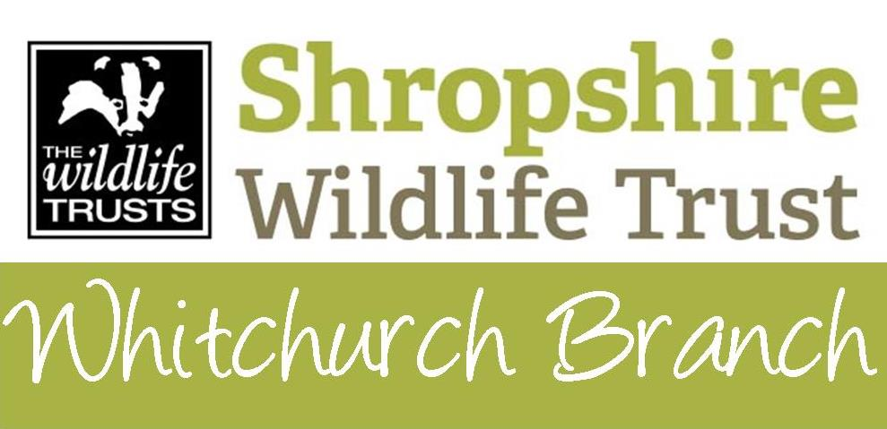

October 2019 – April 2020

All talks start at 7.30 pm at Whitchurch Infant & Nursery Academy
off Station Road, SY13 1RJ [Grid ref SJ 547 413]
Wildlife Trust members £3, Non-members £4, u18s £1, incl tea/coffee from 7.15pm
Wednesday  9th October | Health & Wellbeing with Wildlife in Mind  Craig Baker  of Shropshire Wildlife Trust's “Live Well, Work Well” project
Wednesday 13th November | Who’s Afraid of the Big Bad Wolf?  Michael Leach, the well-known wildlife author and cameraman
Wednesday  11th December | Member's Night and raffle  Five short talks and seasonal refreshments. Offers of talks welcome. Details will be published nearer the time
Wednesay 8thJanuary | Bring Back the Beavers  Stuart Edmunds of Shropshire Mammal Group & SWT
Wednesday  12th February | Pipistrelles to Horseshoes  Mike Worsfold of Shropshire Bat Group
Wednesday  11th March | Restoring the Marches Mosses  Mike Crawshaw, Community Engagement Officer, BogLIFE project
Wednesday  8th April | Making a Wild Future: from Scrapyards to Beavers  Colin Preston, CEO of Shropshire Wildlife Trust  The talk will follow the branch AGM

Monthly working parties at Greenfields Local Nature Reserve
These are usually on the 3rd Tuesday. If you want further details or are interested in helping and can come along anytime between 9.30am and 3.30pm, then please let Malcolm know on 01948 663069 or email whitchurch@ShropshireWildlifeTrust.org.uk
Greenfields LNR is on Facebook

Further details are posted on the Whitchurch Branch web pages
https://www.shropshirewildlifetrust.org.uk/local-branches/whitchurch-branch

Further information: 01948 663069 or email whitchurch@ShropshireWildlifeTrust.org.uk

Please note that the contact information given in the current Events Guide is wrong!

